Warning devices  Verify Check  Horn  Amber flashing beacon  Motion alarms  Raise & lower alarms  Out of level alarm  Verify Check  Basket  Cleanliness  Operator restraint  Instruments & labeling  Levers / controls  Pedals  Log book  Deadman switch  operating instructions  (available on plant) | Supplier verification & Plant details
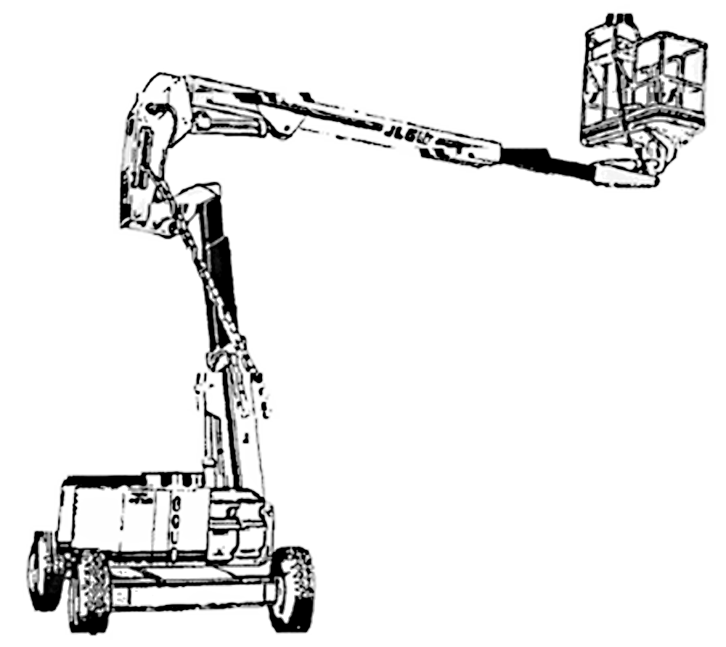 | Plant owner:
 | Address:
 | City/Suburb:
Hydraulics  Verify Check  Rams  Hoses  Connections  (check for excessive  wear, leaks and creep) | Phone:
Verify Check  SWL / Crane Chart | Plant make:
 | Plant model:
Verify Check  Warning signs (in cabin)  SEAT BELTS MUST BE WORN  Verify Check  DANGER – BEWARE OVERHEAD WIRES  & SERVICES  Verify Check  Pivots  Connecting Rods  Safety Pins  (no excessive wear)  Verify Check  Safety Harness & Lanyard | Serial no.:
 | Signature:
 | Date:
 | Work Cover Certification – WP
Verify Check  Exhaust  (if applicable)  Verify Check  Levers / controls  Verify Check  Rams  Hoses  Connections  (check for excessive wear, leaks and creep)  Hydraulics  Verify Check  Engine guarding |  Plant to conform to manufacturer’s specifications and Plant Regulations.   Plant operator is to provide daily checksheets to WDA on a weekly basis.   Where applicable, Personal Protective Equipment must be worn.   Plant Log Book detailing service history in accordance with Manufacturer’s specifications should be written legibly in English.   Contractor must produce proof of competence of operator, e.g., Certificate of Competence, Licence, detailed Log Book
Verify Check  Tyres  Wheels  Brakes  Park brake | WDA use only
 | Note: Sign only when all items have been checked
 | Plant check by:
Instructions:  Verify Box to be ticked by Owner / Supplier / Operator prior to arrival onsite.  Check Box to be ticked after visual inspection by WDA | Position:
 | Date: |  | / /

